Talaria TWO modules are shipped with a default Factory Loader (FL) program that assists in programming customer applications at a production facility using:

1. UART/SPI only or
2. Serial Wire Debug (SWD) or
3. A combination of UART/SPI/SWD and Wi-Fi

The FL application along with companion scripts are available in InnoPhase customer portal (<https://innophaseiot.com/portal/portal-hub/>). The FL content is described in Table 1:

|  |  |
| --- | --- |
| **Filename** | **Description** |
| factory_loader.elf | Factory loader application in .elf format |
| factory_loader.img | Factory loader application in .img format |
| factory_loader.py | Companion script for the factory loader application |
| api/factory_loader.py | Factory loader HIO API |
| helloworld_config.json | Simple helloworld application json configuration file |
| fota_config.json | Advanced FOTA application json configuration file |
| UFS/* | Directory for sample user filesystem |
| ELFS/* | Directory for sample prebuilt applications |

Table 1: FL files with description

The entire process of factory loading is configured using a JSON config file. On Talaria TWO, the factory loader application awaits instructions from a HOST PC/system running the factory loader script. The factory loader script takes a JSON config file as an input. This JSON file is parsed by the factory loader script to automate all programming, such as building the filesystem and programming the Talaria TWO.

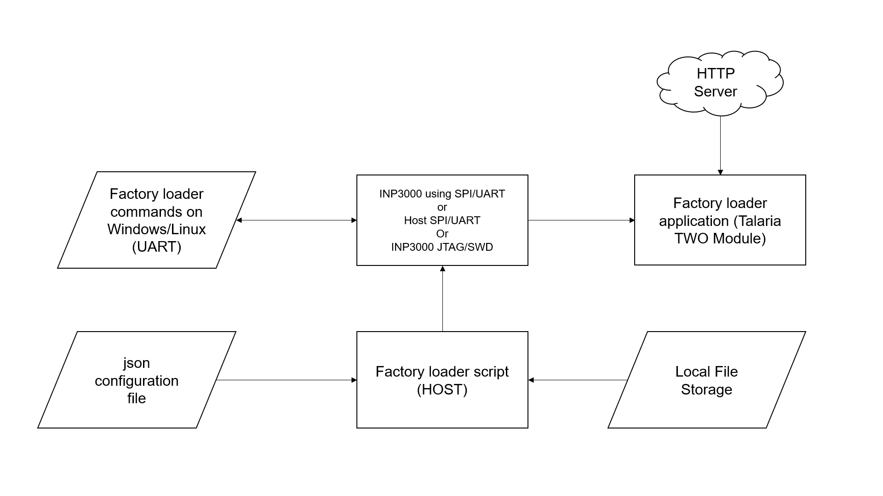

Figure 1: Factory Loader block diagram

## Prerequisites:

1. Develop applications using the evaluation board or an application such as AT-commands offered by InnoPhase IoT.
2. Be familiar with Talaria TWO devices’ flash memory layout and make key decisions such as using secureboot.

Test the factory loading process using the EV boards prior to production deployment.

## Talaria TWO Flash Layout

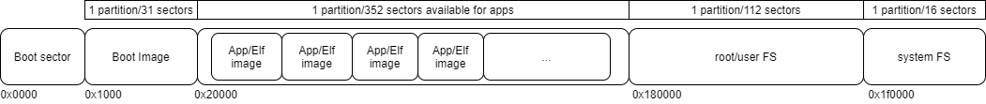

Figure 9: Flash Layout using SSBL

### Boot Sector

The Boot Sector contains data such as:

1. Devices keys
2. Factory_code
3. Partition table
4. Device information

It is recommended that this section be modified only once during the factory programming process.

### Boot Image

The Boot Image is the default application image that is loaded with every boot. It is stored at fixed location in flash at 0x1000. The factory loader is programmed by default.

### Application Sector

The application sector is used to store one or more user applications. Applications should be flashed in a stripped ELF format to conserve space.

### System Filesystem

The System Filesystem is reserved for use by the Talaria TWO firmware.

**Note**: Users **should not** modify this location.

### Root/User Filesystem

The root/user filesystem is available for use by the application to store application data. The SSBL reads certain files from this filesystem to determine the application to run from the application sector.

## InnoPhase ELF Layout

Figure 10: ELF Layout

Each application in the application sector is stored as shown in Figure 10. In case of a non-VM based application, the .virt section is not present.